Practical activity: Electroplating
Practical Demonstration Guide – Electroplating

Aim: To plate a piece of copper metal with zinc.
Notes and guidance
This demonstration can be carried out as a class practical if done on a small scale.

Electroplating can be demonstrated with other metals, but zinc chemicals are generally less toxic.

The electrolyte solution used has a low concentration of the hydrated metal ions required for plating and a high total concentration of ions, which results in good conductivity.

If possible, conduct this demonstration with a clean copper coin. This is a much more interesting subject for students than a piece of copper foil as it can open up discussions about how coins are made and counterfeited.

Legal note: although it is illegal in the UK to destroy currency, electroplating does not ‘melt down or break up’ the coin, so it is not covered by the legislation. Furthermore, the copper coin can be returned to as-new condition through cleaning.

Risk Assessment Notes
A risk assessment must be completed for this practical. The risk assessment should be specific to the class involved and written only by the teaching member of staff. For more guidance refer to CLEAPSS. It is good practice for students to wear safety spectacles during all class practicals and demos.

Ensure that power supplies are locked so they cannot exceed 6 V. Liquids should be kept a safe distance from power supplies and any spills should be cleaned up immediately.

Equipment | Simple Electroplating Setup  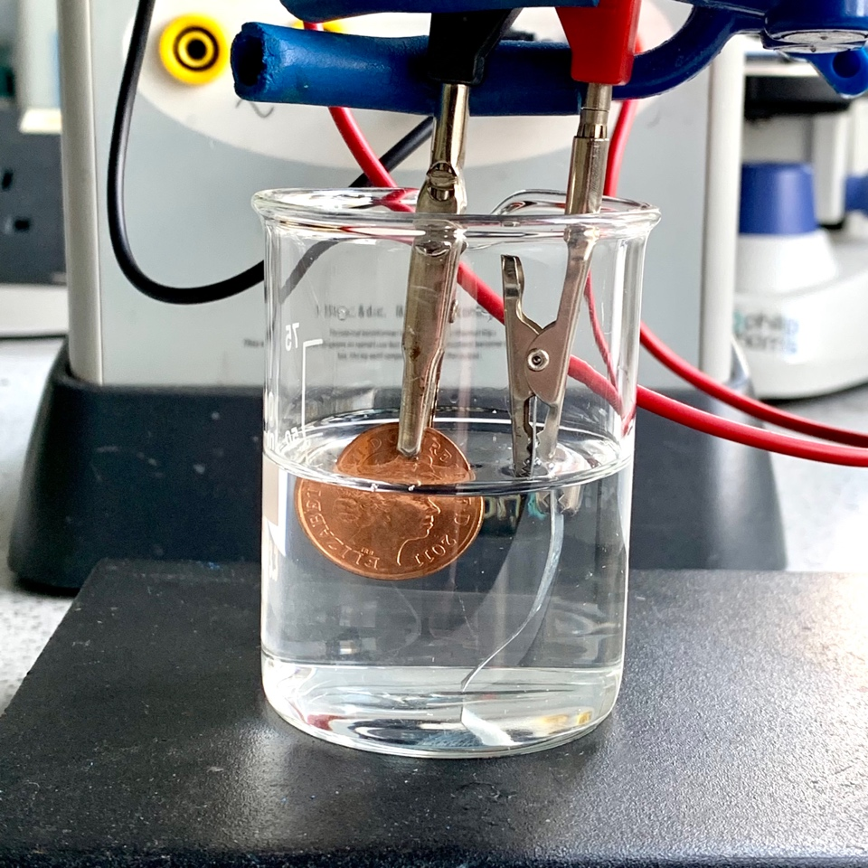
Apparatus:
- Small beakers
- Copper coin or foil
- Zinc foil
- Powerpack locked to 6 V
- Wires
- Crocodile Clips
- Electrode holder or clamp
- Tongs
- Bunsen burner
- Heatproof mat
- Paper towel

Chemicals:
- Electrolyte solution – 6:1 ratio of 0.4 M sodium hydroxide and 0.1 M zinc sulfate(VI) solution
- 0.5 M nitric acid
- Access to water
- 1 M sulfuric acid

Method |  | Questions To Ask Students During The Demonstration
Part one:  - Using plastic forceps, dip the copper cathode into 0.5 M nitric acid. Hold it in the acid until the surface of the metal is clearly clean and shiny. Rinse the cathode in water and dry with a paper towel.  - Pour a small amount of electrolyte solution into the small beaker.  - Attach crocodile clips to the zinc anode and copper cathode and position these securely in the beaker with the electrode holder or clamp.  - Connect the zinc anode to the positive terminal of the 6 V power supply.  - Connect the copper cathode to the negative terminal of the 6 V power supply.  - Switch on the power supply and observe as the copper becomes plated with zinc.  - Repeat the above for a second piece of copper.  Part two:  - Light your Bunsen burner and set it to a roaring flame.  - Holding one of the zinc-plated copper in metal tongs, pass it through the flame quickly.  - Observe the change to the appearance of the copper.  Part three:  - Place the other piece of zinc-plated copper into a beaker of 1 M sulfuric acid and observe the change to its appearance. |  | - Why is it important to ensure the two electrodes do not touch one another? (This would create a short circuit and no electricity would pass through the electrolyte solution.)  - Why is it important to clean the copper before electroplating? (To remove any dirt between the copper and the electrolyte that would prevent electroplating.)  - What does the copper look like after electrolysis? (It has a silver appearence.)  - Why is this? (It has been electroplated with zinc.)  - What does the zinc-plated copper look like after it has been heated in the Bunsen burner? (It has a golden appearence.)  - Why is this? (The zinc melts into the top layer of the copper forming a bronze alloy.)  - What does the zinc-plated copper look like after it has been placed in the sulfuric acid? (It returns to its original copper colour.)  - Why is this? (The layer of zinc plating reacts with the acid to become zinc sulfate.)
Clearing up
It is important that equipment is returned to the prep room in good order. If safe to do so, rinse used equipment and put it in the used equipment tray. If the trays arrived on a trolley, students must return all trays and equipment to that trolley. Anything dirty needs to be placed into a separate container for washing up. Never put dirty equipment back into a tray with clean equipment.

The electrolyte solution can be poured down a foul water drain after heavy dilution.

Hoffman Voltameter
This is an expensive and delicate piece of equipment, it is recommended that this experiment be carried out as a demonstration. See the ‘alternative methods’ section for another approach that can be used if the equipment is not available or if you wish for students to carry out a version of this experiment themselves.

Dedicated electrolysis chambers are available for purchase from many scientific suppliers. These consist of a cylinder of metal that can fit over a two-hole bung with protruding electrodes. The benefit of these is that they require much less solution per experiment, and also allow for easy collection of any gases generated via upturned ignition tubes over each of the electrodes. These are not a perfect alternative for a Hoffman Voltameter, but they can be used in a pinch to show the same principles.

Technician Notes
Ensure the solutions you provide are free from contamination and the equipment is as clean as possible.

Discuss this practical with the class teacher ahead of time. Ensure they have considered the risks of this practical and are confident with the techniques used. If necessary, provide them with the appropriate CLEAPSS so they are comfortable with the chemicals to be used and how to use and dispose of them safely.

If your school’s powerpacks can be locked, lock them to 6 V.

